Description on how to download Last Trade Data from SETTRADE and Historical Data from SET:

Approach: Use Last-Trade Download to automatically collect and update ticker lists, while capturing last-trade data. Then use Daily Download to capture past 6 months data.

Last-trade data for Thailand SET and mai markets are available at www.SETTRADE.com. Data can also be retrieved by Industry or Sector. For example, SET100 index component data can be manually accessed from:
http://www.settrade.com/C13_MarketSummary.jsp?detail=SET100&order=N&industry=&sector=&sectorName=O_SET100

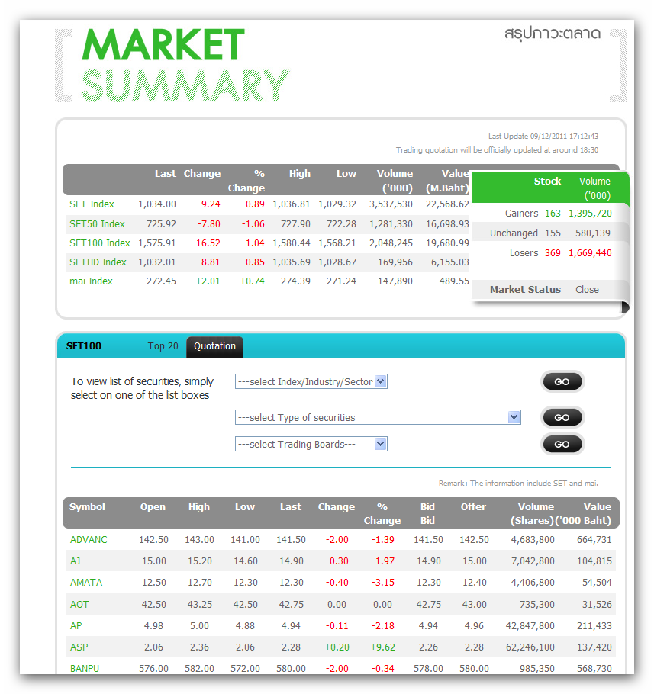
Specific Industry, such as Finance, can be accessed from:
http://www.settrade.com/C13_MarketSummary.jsp?detail=INDUSTRY&order=N&industry=FINCIAL&sector=&sectorName=I_FINCIAL

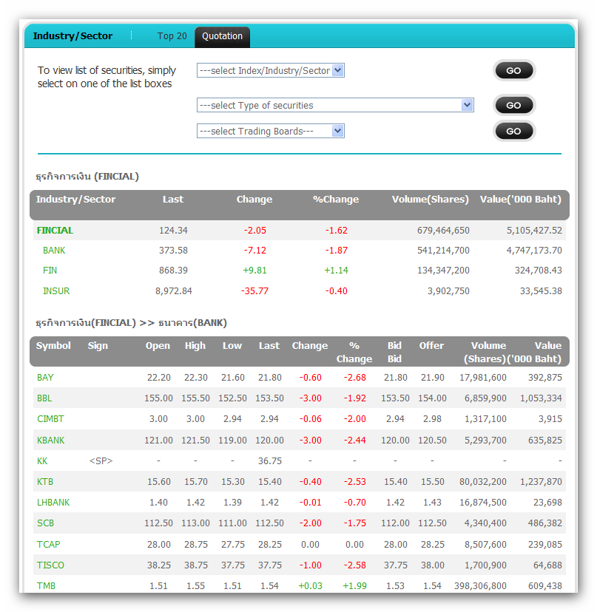

The format file for industry and sector data is slightly different from that for the stock data, while the URLs are all different. For automatic data retrieval, and for the sake of sharing similar format files, we shall 3 separate lines with different URLs but just 2 format files (SETTRADE_L3.fmt and SETTRADE2_L3.fmt).

Set-up:

- Copy the following lines and append to your existing “mywebserver.txt”, or simply substitute it with the attached “mywebserver.txt”.

Thai_Stock_XXXX,http://www.settrade.com/C13_MarketSummarySET.jsp?command=XXXX,L3,SETTRADE_L3.fmt
Thai_Industry_XXXX,http://www.settrade.com/C13_MarketSummaryIndustry.jsp?sector=&industry=XXXX,L3,SETTRADE2_L3.fmt
Thai_Sector_XXXX,http://www.settrade.com/C13_MarketSummaryIndustry.jsp?sector=XXXX&industry=,L3,SETTRADE2_L3.fmt
- Copy the “SETTRADE_L3.fmt” and “SETTRADE2_L3.fmt” to the “fmt” subfolder in the Data File Location (indicated on the Preference Setting screen).
- Run HSQuote Plus and set up “Thai_Stock_XXXX.tic”, “Thai_Industry_XXXX.tic”, and “Thai_Sector_XXXX.tic” as shown below. Please take note that you need to replace the “XXXX” here with the specific Index, Industry or Sector. The examples here use SET100 Index, PROPCON Industry, and PROP Sector within the PROPCON Industry. You can add more ticker lists similarly.

Also note that you do not need to provide the Tickers, just leave the Ticker windows blank. The SETTRADE_L3.fmt has indicated to renew tickers before each download (in case tickers have changed):
1@myRenewTickers#Renew Ticker List before download (default: 0, No)

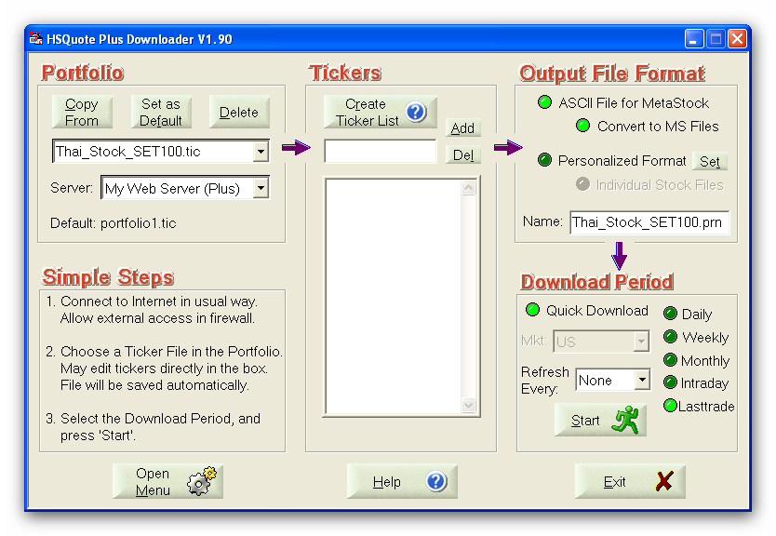

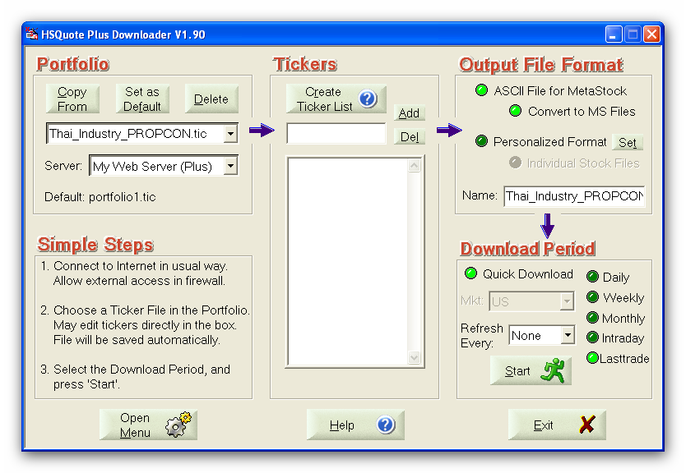

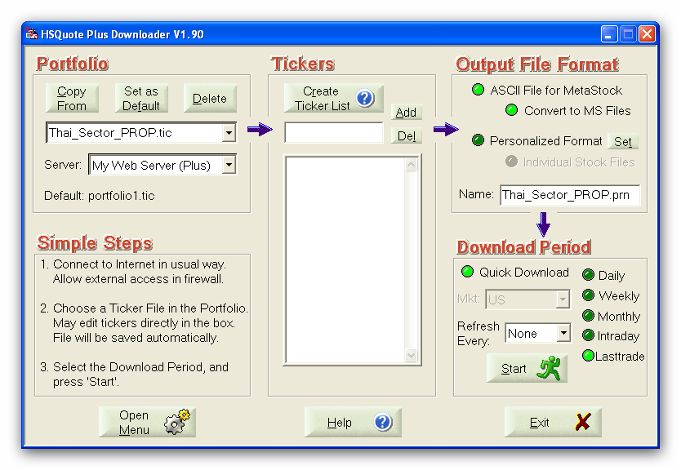

1) Last-Trade Data Download to Collect/Update Ticker Lists:

As 6 months of historical daily data are available at the SET website (described below), we shall only use the Last-Trade data download mainly to collect or update ticker lists or when you need last-trade intraday or close data before they are available on the SET historical data server.

All you need is to select “Lasttrade”, and click on the “Start” button!

2) Historical Daily Data Download:

6 months of historical daily data are available at the SET website. For example:

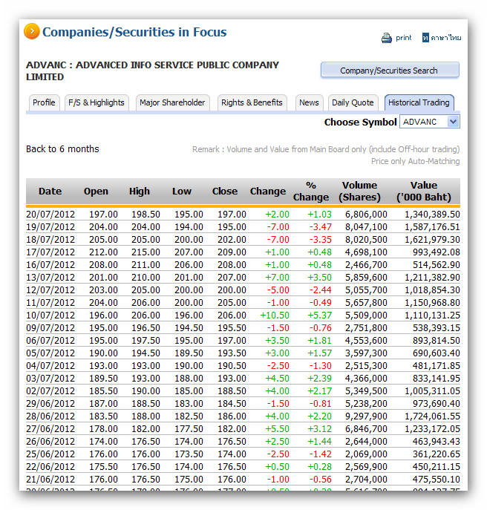
Set-up:

- Copy the following lines and append to your existing “mywebserver.txt”, or simply substitute it with the attached “mywebserver.txt”.

Thai_XXXX,http://www.set.or.th/set/historicaltrading.do?symbol=SSSS&page=NNNN&language=en&country=US&type=trading,D1,SET_D1.fmt

- Copy the “SET_D1.fmt” to the “fmt” subfolder in the Data File Location (indicated on the Preference Setting screen).

- Run HSQuote Plus and set up “Thai_Stock_XXXX.tic”, “Thai_Industry_XXXX.tic”, and “Thai_Sector_XXXX.tic” if not already set up in the “Last-trade download” section above. Note that we are using the same Ticker Lists.

Download:

Just select the Download Period, and click on the “Start” button!

